PIP5K1A correlation with immune infiltrates in pancreatic adenocarcinoma (PAAD)
The correlation analysis was done on TIMER3 webtool by compbio. The results obtained matched the previous results exactly, validating the analysis. A table summarising the statistics can be seen below, followed by individual correlation plots for each category. Correlations that were statistically significant are highlighted (red-positive correlation, blue-negative correlation).
 | Purity |  | Infiltration level
 | Rho | P value | Rho | P value
Tumor purity | 0.038 | 0.6 | -0.069 | 0.3
Stroma score | 0.038 | 0.6 | 0.148 | 0.05
Immune score | 0.038 | 0.6 | -0.016 | 0.8
Cancer associated fibroblast | 0.038 | 0.6 | 0.332 | 0.000009
Common myeloid progenitors | 0.038 | 0.6 | -0.08 | 0.3
Endothelial cells | 0.038 | 0.6 | 0.154 | 0.04
Tumor CD274 | 0.038 | 0.6 | 0.466 | 0.1
Myeloid-derived suppressor cells | 0.038 | 0.6 | 0.366 | 0.0000009
Interferon gamma | 0.038 | 0.6 | 0.198 | 0.009
Common lymphoid progenitors | 0.038 | 0.6 | 0.277 | 0.0002
NK cells activated | 0.038 | 0.6 | -0.254 | 0.0008

- Correlation with tumour purity (not significant)
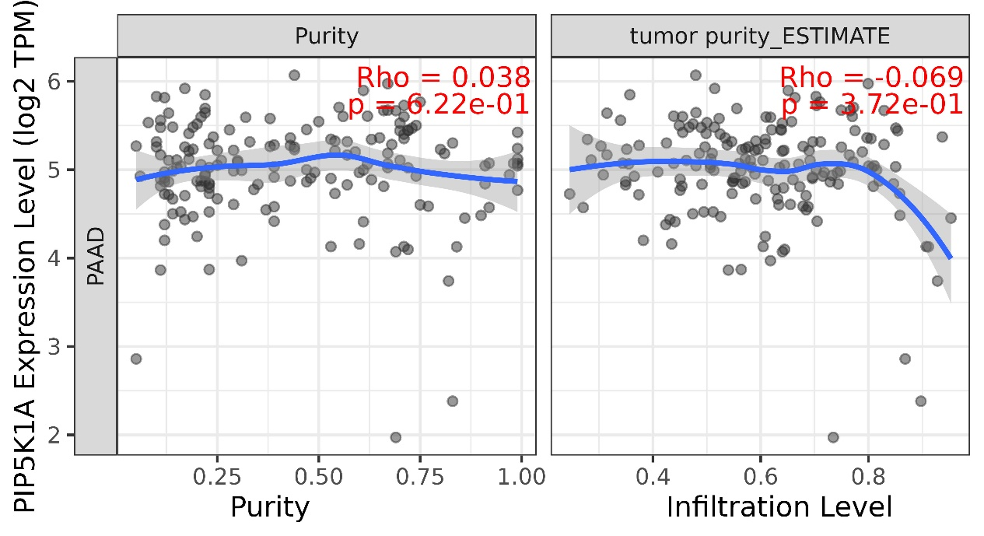
- Correlation with stroma score (not significant)
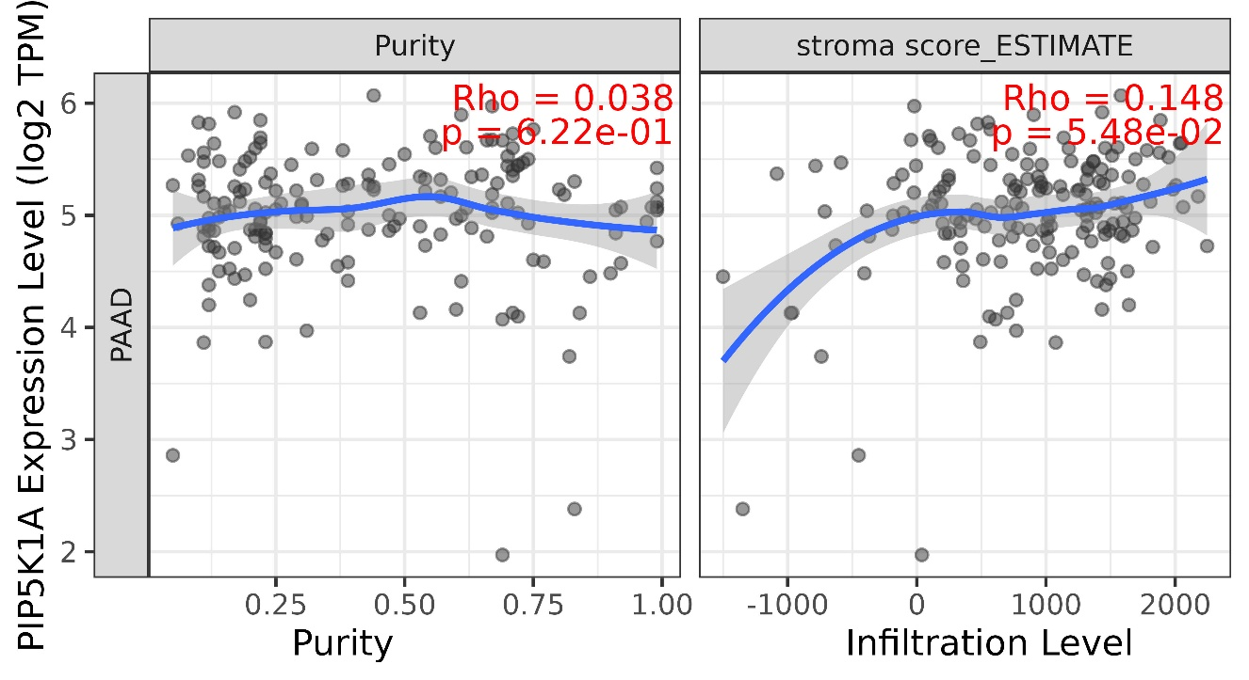

- Correlation with Immune score (not significant)
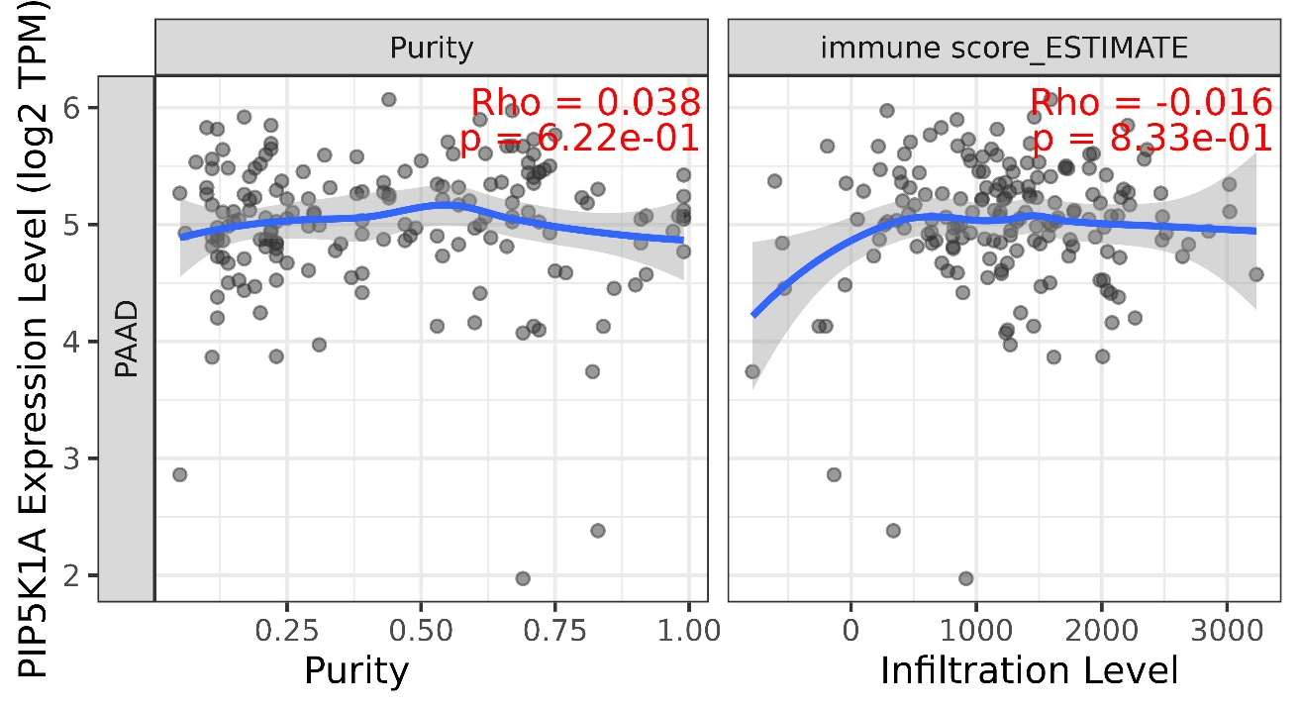
- Correlation with cancer associated fibroblasts EPIC (positive correlation)
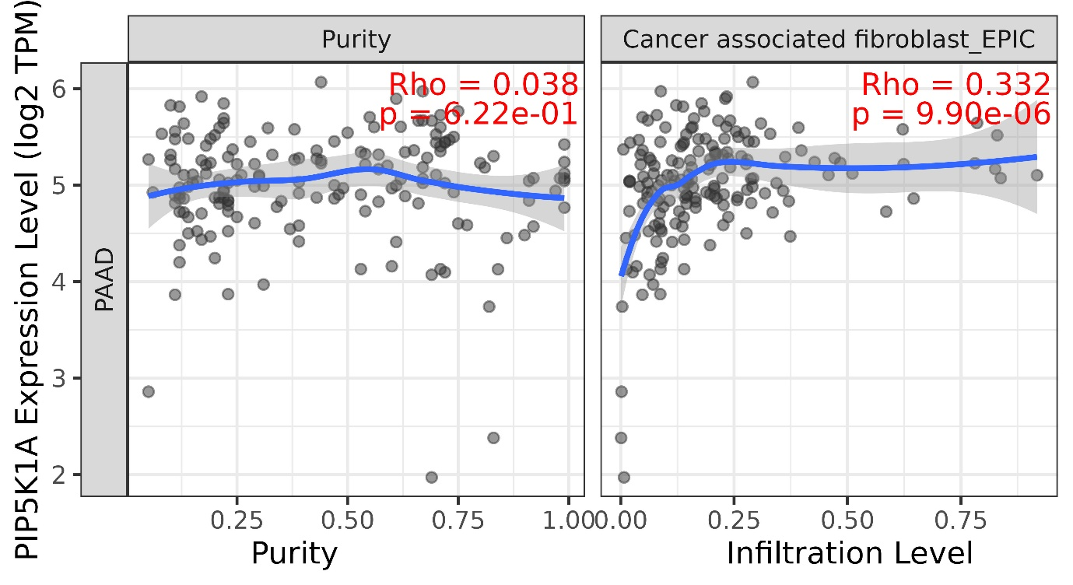
- Correlation with common myeloid progenitors (not significant)
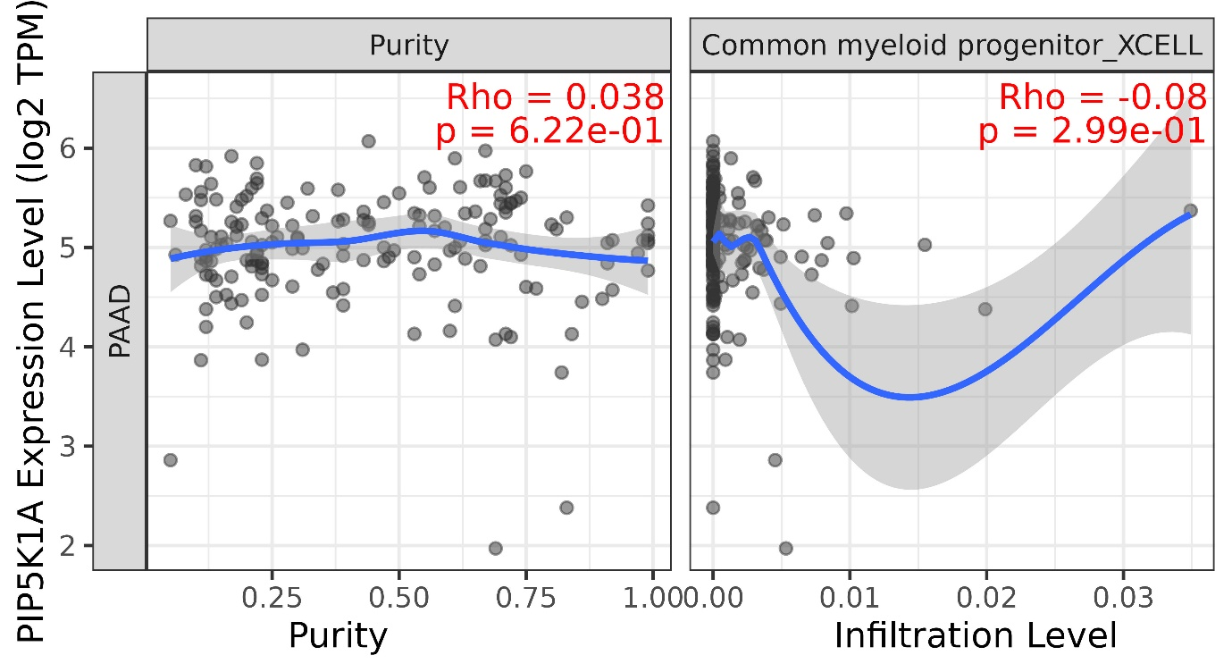
- Correlation with Endothelial cells EPIC (positive correlation)
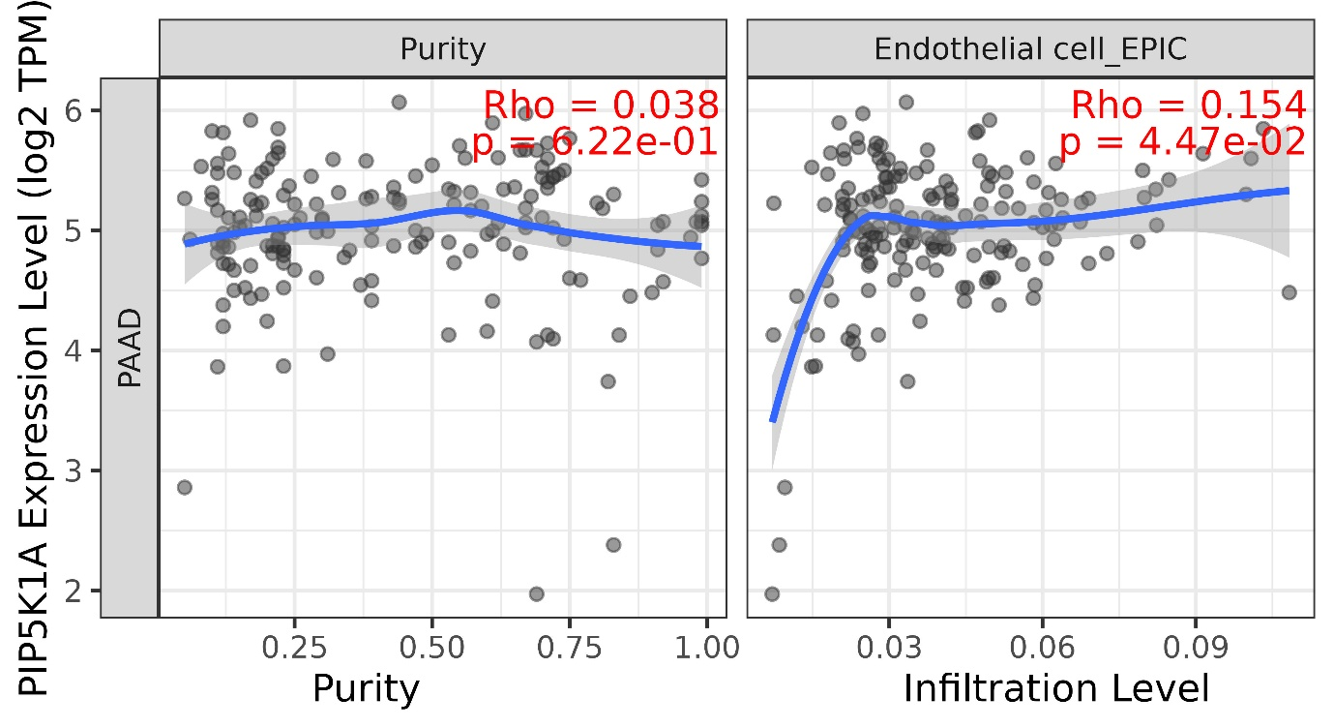

- Correlation with CD274 (positive correlation)
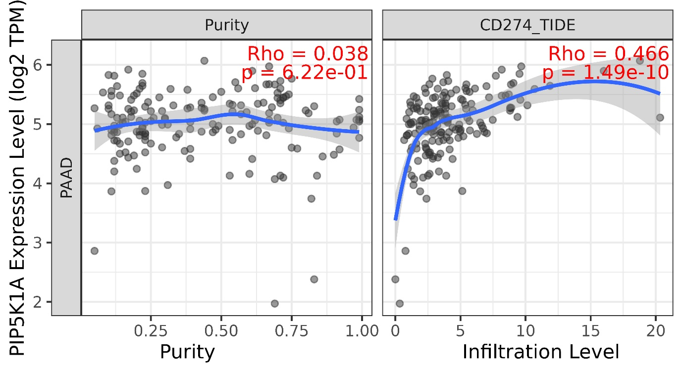
- Correlation with MDSCs (positive correlation)
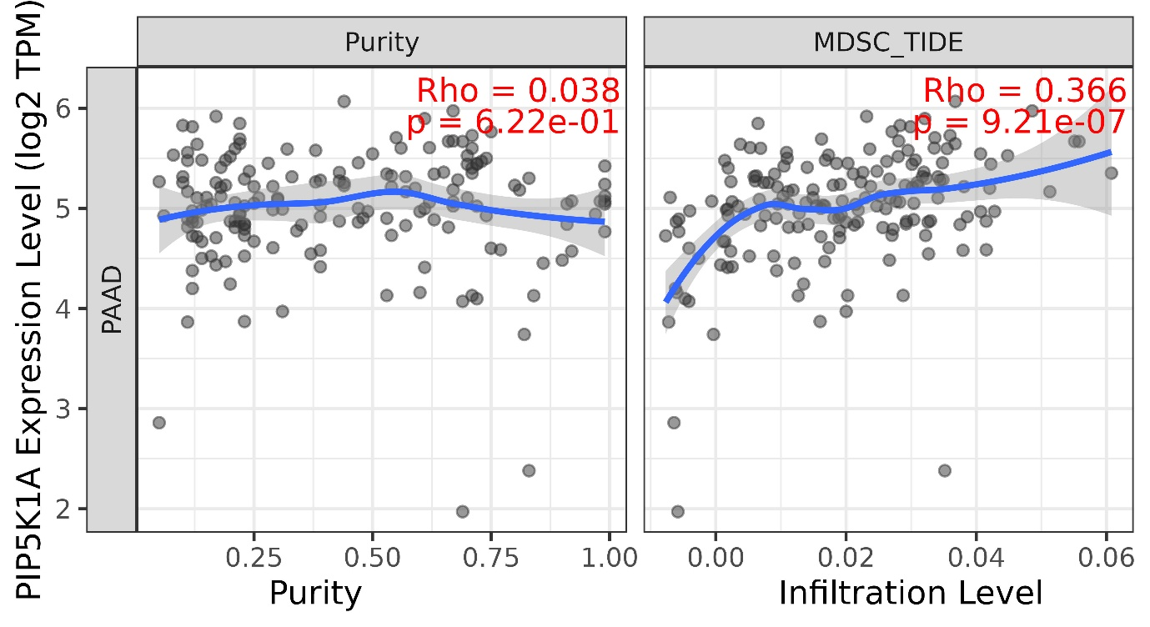

- Correlation with interferon gamma (positive correlation)
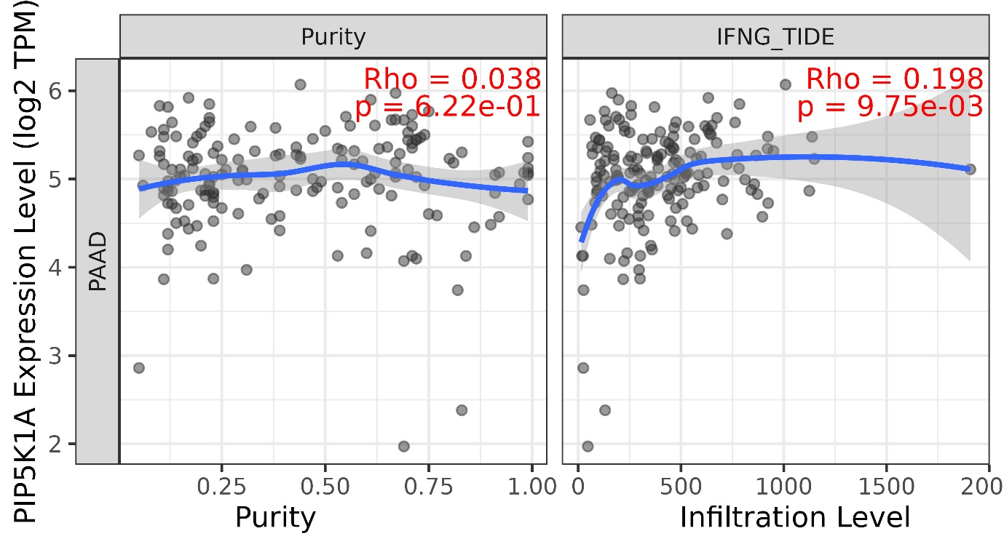
- Correlation with common lymphoid progenitors (positive correlation)
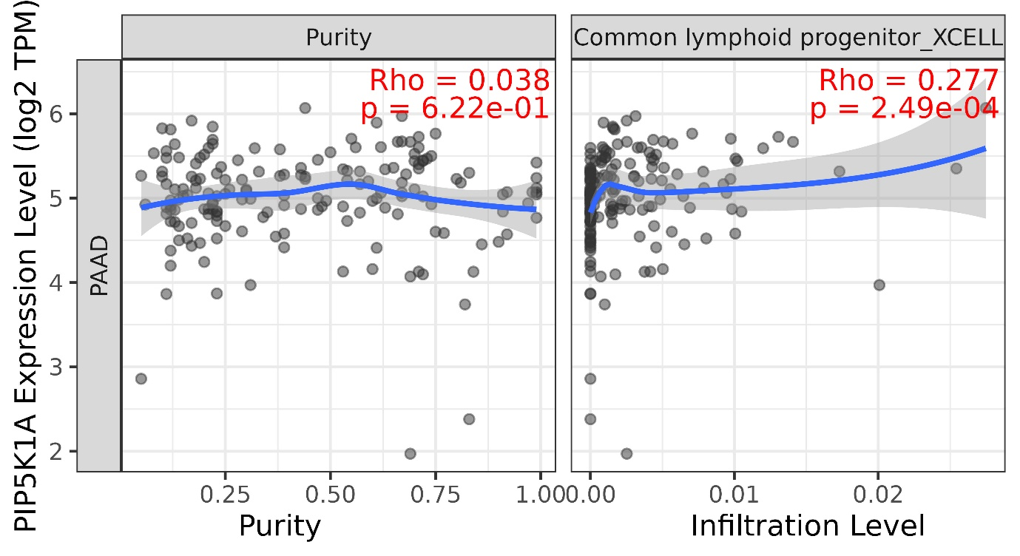

- Correlation with NK cells activated (negative correlation)
